Water Street by Crystal Wilkinson 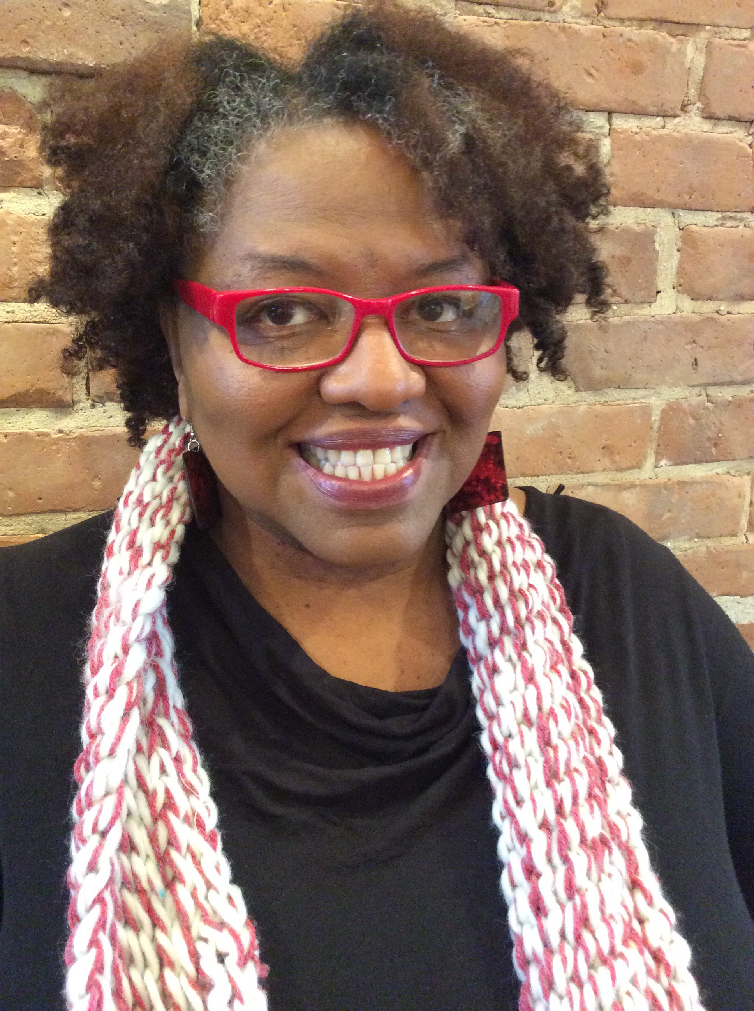 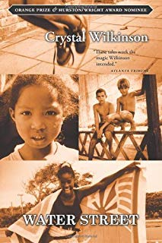
Before you read any of the selections from Water Street, click on the Appalachian Heritage Writer-in-Residence (AHWIR) website and read about Crystal Wilkinson; explore some of the links on the pages, In Her Own Words and Teaching Tools and Resources. This is a collection of related stories, or a cycle collection, similar to Sherwood Anderson’s Winesburg, OH. As you read, notice the connections between the characters in these stories about small-town life in Appalachia; and if you read other Wilkinson books, continue to notice those connections, though you will find each volume has a different focus for these common characters. Water Street deals with the secrets that neighbors have and the discrepancy between appearance and reality, between what one shows the world for public consumption and what goes on behind closed doors. Those mysteries and that divide between truth and appearance do more than just affect one’s peace of mind.

As you read, keep in mind Crystal Wilkinson’s enjoinder about reading these Affrilachian stories: “We are almost Southern but not northern at all. . . . In the summer you will see our cinnamon sons, our dusty daughters . . . every person has at least two stories to tell. One story that the light of day shines on; the other that lives only in the pitch of night, the kind of story carried beneath the breastbone, near the heat, for safekeeping” (1,3). As you read these stories, you will find a decided clash between how characters appear and how they are. Notice also the likewise non-linear style of Wilkinson’s storytelling. For example, in “My Girl Mona,” Yolanda is talking to her Black therapist, and the narrative interplays between that present conversation and her thoughts back in time about her friend Mona, by whom Yolanda feels betrayed. A refrain throughout is “You know what I mean”—why does Yolanda keep repeating this phase to her therapist? Do any of us know what each other really means? How does adolescence interfere with the friendship of Yolanda and Mona? In the story “Water Street, 1979,” Junior, Yolanda’s boyfriend and later her husband comes to terms with the racial divide and the relationship between Blacks and Whites; what does he learn about both races? What do “An Ordinary Man” and “Between Men” have to say about being a man in contemporary society? Do you think this point of view is fair to men? In “The Fight” what do Candy and the narrator learn about their mother? What does the family reunion tell us about human nature in “The Evolution of Sandy Crawford”? On KiKi’s wedding day in “The Girl of My Dreams,” what is on Yolanda’s brother’s mind as he prepares for the big event? How is this volume a critique of patriarchy, even as it finds fault with both genders? Finally notice how some of the stories are paired—the best example is “Sixteen Confessions of Lois Carter” and “Respite.” These two touching stories gently explore the clash of White and Black cultures and the racial divide in still present in America—as wife Lois and mother-in-law Pearline experience the dynamics of their cultural differences. Of course, our hope for bridging differences and coming to an understanding of those who differ from us is in our children.

